Master of Science (IT) Sem – 05



Lj School Of Computer Applications

Task Management with collabration

Guided by:

Developed by:

|  |  |
| --- | --- |
| Name | Enrollment |
| Arnold Macwan | 21004500210065 |
| Manthan Parmar | 21004500210094 |

Lj School Of Computer Applications

Near Nagdev Kalyan Mandir, Near Sanand Cross Roads,

SG Highway Ahmedabad – 382210

Ph. No.: 9099063417



Enrollment No: 21004500210065

This is certified that Arnold Macwan of Master of science (IT), Semester 07, Roll no 28 has satisfactorily completed his project titled Task management with collaboration under the supervision of internal guide.

Internal guide: HOD:

Dr. Jignesh Doshi

Lj School Of Computer Applications

Near Nagdev Kalyan Mandir, Near Sanand Cross Roads,

SG Highway Ahmedabad – 382210

Ph. No.: 9099063417



Enrollment No: 21004500210094

This is certified that Mathan Parmar of Master of science (IT), Semester 07, Roll no 43 has satisfactorily completed his project titled Task management with collaboration under the supervision of internal guide.

Internal guide: HOD:

Dr. Jignesh Doshi

|  |  |
| --- | --- |
| Sr.  No. | TABLE OF CONTENTS |
| 1. | INTRODUCTION |
|  | 1.1 Existing System |
|  | 1.2 Need for the New System |
|  | 1.3 Objective of the New System |
|  | 1.4 Problem Definition |
|  | 1.5 Core Components |
|  | 1.6 Project Profile |
|  | 1.7 Assumptions and Constraints |
|  | 1.8 Advantages and Limitations of the Proposed System |
| 2. | REQUIREMENT DETERMINATION & ANALYSIS |
|  | 2.1 Requirement Determination |
|  | 2.2 Targeted Users |
| 3. | SYSTEM DESIGN |
|  | 3.1 Use Case Diagram |
|  | 3.2 Class Diagram |
|  | 3.3 Sequence Diagram |
|  | 3.4 Activity Diagram |
|  | 3.5 Data Dictionary |
| 4. | DEVELOPMENT |
|  | 4.1 Coding Standard |
|  | 4.2 Screenshots |
| 5. | AGILE DOCUMENTATION |
|  | 5.1 Agile Project Charter |
|  | 5.2 Agile Roadmap / Schedule |
|  | 5.3 Agile User Story |
|  | 5.4 Agile Release Plan |
|  | 5.5 Agile Sprint Backlog |
|  | 5.6 Agile Test Plan |
| 6. | PROPOSED ENHANCEMENTS |
| 7. | CONCLUSION |
| 8. | BIBLIOGRAPHY |

1. Introduction

* Managing and monitoring tasks is essential during the any kind of product development process. Handling things manually can be rather chaotic at times, especially when a large number of individuals are engaged.
* The "TaskQuest" platform helps users organize and manage team work, get updates, and prioritize reminders.
* The system offers important functions such as progress monitoring, process reporting, collaborations, and quick interaction to improve productivity and efficiency. Team members can remain on top of their work and avoid mistakes.
* The real-time collaboration features empower teams to work together, share updates, and discuss tasks within the app, enhancing productivity and communication.
  1. Existing System
* The features and functionality of existing task management systems differ but they often include tools for project management, work assignment, and progress monitoring.
* Some existing system doesn’t have robust and secure platform to work in which security is a concern.
* For small teams or users new to platform to work may be overly complex and difficult to learn. It may cost some extra charges to organization.
* Although most systems offer collaboration tools, not all provide seamless real-time updates, which can delay communication and task tracking.
  1. Need for New System
* The new system can be used to manage the cases more accurately and efficiently.
* System will provide the report generating, organize tasks, real time updates, get reminders and analysis and many more functionalities.
* The need for software that can process information much faster than existing and can therefore help to increase the flow of work and timely availability of information was inevitable. In order to satisfy all above requirement, this software system has been developed and enhanced.
  1. Objectives for New System
* The aim of creating the task management web app with collaboration is to deliver an easy, efficient, and scalable solution that improves task organization, team communication.
* In order to streamline the task allocation and tracking with team member and provide collaborative feature, the system has been implemented
  1. Problem Definition
* “TaskQuest” - Task management and collaboration systems achieve the demands of project processes. It provides a platform and allows features to be worked on “Role based access control” and with real time collaboration behaviour to organise the tasks.
  1. Core components
  2. Project Profile

|  |  |
| --- | --- |
| Project Name | TaskQuest |
| Front-end | ReactJS, Tailwind CSS |
| Back-end | ExpressJS |
| Libraries | Material UI |
| Database | MongoDB |
| Tools | MS-OFFICE, DIA Builder, creatly |
| IDE | Visual Studio Code |

* 1. Assumptions & Constraints
* Assumptions:
  + User must need to understand the system to use the system
  + Users will have a reliable internet connection to guarantee that real-time collaboration, data synchronization, and communication functions operate properly.
  + The app assumes an online, real-time environment. Developing an offline mode for users in areas with limited internet access would require additional resources and complex synchronization protocols.
* Constraints:
  + Lack of Backup services
  + Less Scalability
  + less payment methods
  1. Advantages & Limitations

1. Requirement Determination

* Requirement determination for task management involves gathering, analyzing, and documenting the needs and expectations of stakeholders.
* This phase is consisting of:
  + Surveys & sampling
  + Client’s requirements
  + Identifying the non-functional requirements
  + Review existing system if available
  1. Targeted Users
* Team leader
* Team member
* Admin

1. System Design

3.1 Use case diagram

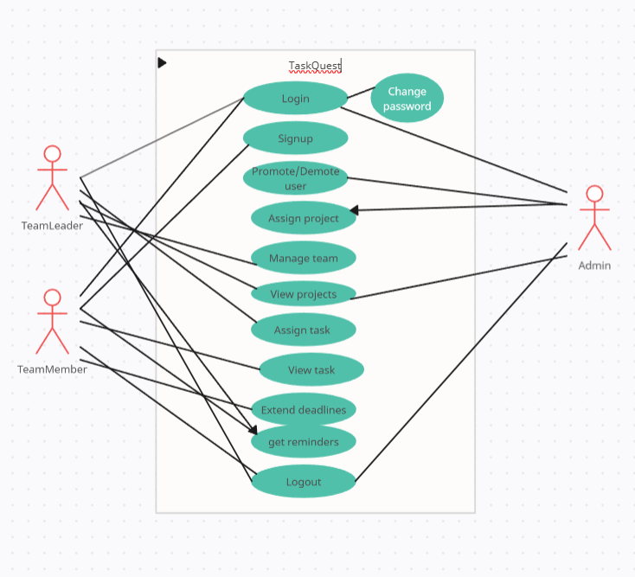

3.2 Class Diagram

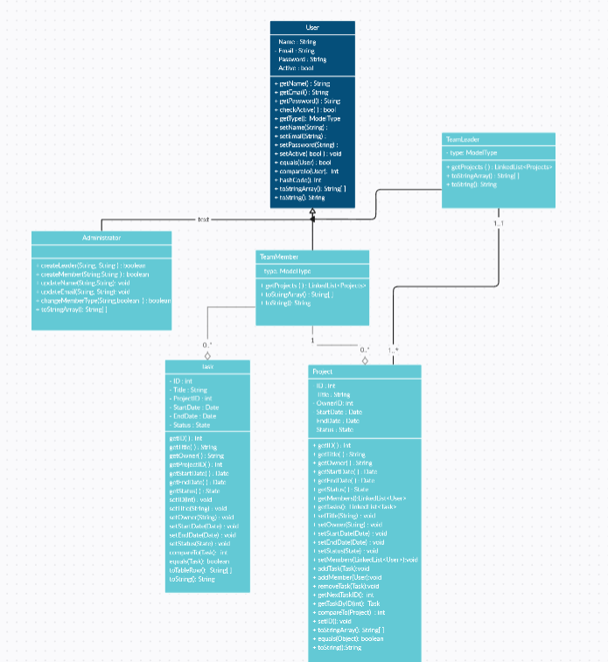

3.4 Activity Diagram

An activity diagram to add task by user

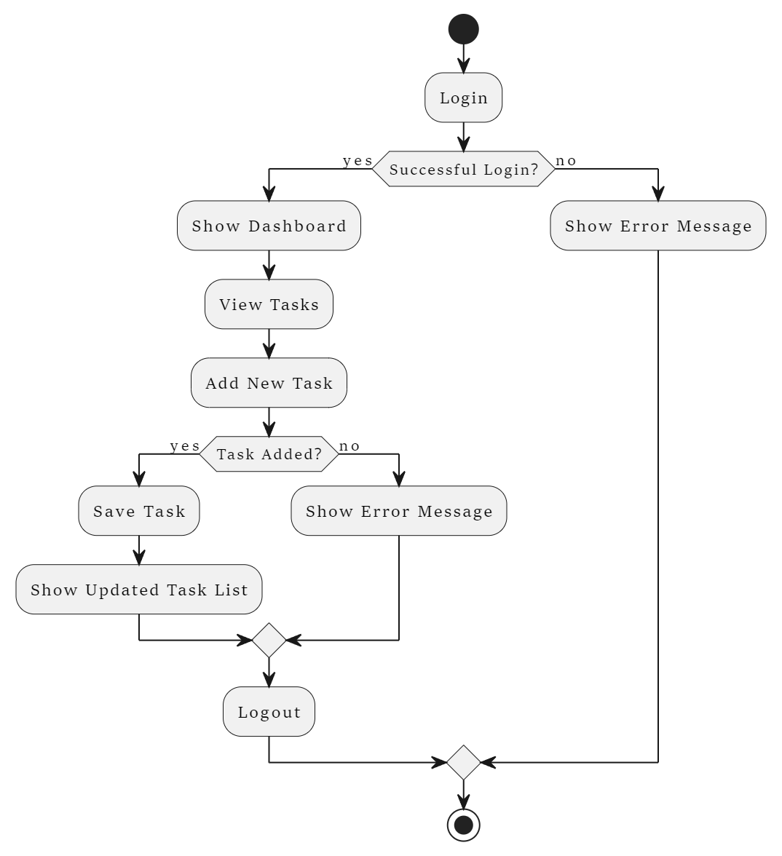

3.5 Sequence diagram

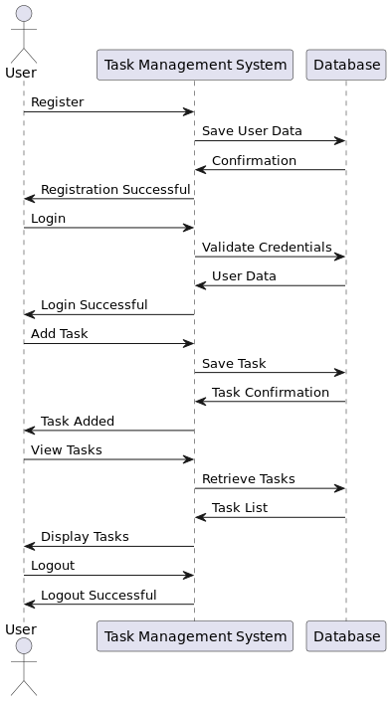

3.5. Data Dictionary

|  |  |  |  |  |
| --- | --- | --- | --- | --- |
| Field | Datatype | Constraints | Description | Sample |
| _Id | Object | primary key | Table id | ObjectId(“ 66d0b4a3ab787645b3291b70”) |
| First name | Varchar2(25) | Not null | Firstname of the user | Arnold |
| Last name | Varchar2(25) | Not null | Lastname of the user | Macwan |
| Email | Varchar2(25) | Unique | Email of the user | [abc@gmail.com](mailto:abc@gmail.com) |
| Password | Varchar2(10) | Not null | Password | abc@123 |
| Userprofile | Varchar2(50) | Not null | Path of image of the user | pics/img.png |

User table

|  |  |  |  |  |
| --- | --- | --- | --- | --- |
| Field | Datatype | Constraints | Description | Sample |
| taskId | Object | Primary Key | Unique identifier for the task | ObjectId(“12c0b...”) |
| title | Varchar(50) | Not null | Title of the task | Design UI |
| description | Text | Not null | Detailed description of the task | Design the login UI |
| status | Varchar(10) | Not null | Current status of the task | Pending |
| priority | Varchar(10) | Not null | Priority level of the task | High |
| dueDate | Date | Not null | Due date for the task | 2024-09-10 |
| assignedTo | Foreign Key | Not null | Links the task to the assigned user | userId |

Task table

|  |  |  |  |  |
| --- | --- | --- | --- | --- |
| Field | Datatype | Constraints | Description | Sample |
| Id | Object | Primary Key | Unique identifier for the team | ObjectId(“12c0b...”) |
| Team_name | Varchar (50) | Not null | name of the team | Frontend Team |
| Members | Varchar (50) | Not null | List of the members | [user1,user2] |

Team table

Comment table

|  |  |  |  |  |
| --- | --- | --- | --- | --- |
| Field | Datatype | Constraints | Description | Sample |
| Id | Object | Primary Key | Unique identifier for the table | ObjectId(“12c0b...”) |
| Author | Foreign key | Foreign key references user table | Links to the user who wrote the comment | userid |
| Date | Date | Not null | Date of the comment received | 20-04-2024 |
| Message | Varchar (250) | Not null | Message description | It was good |

Project table

|  |  |  |  |  |
| --- | --- | --- | --- | --- |
| Field | Datatype | Constraints | Description | Sample |
| Id | Object | Primary Key | Unique identifier for the table | ObjectId(“12c0b...”) |
| Name | String | Not null | Name for the project | Chatify |
| Teams | Array | - | Stores the teams associated with project | [t1,t2] |
| Assigned to | String | Not null | Stores the detail of leader project assigned to | John Doe |
| Created_at | Date | Default | Timestamp at time of creation | 12-05-2023 |
| Status | String | - | Status of project | Delayed |
| Due date | Date | - | Deadline date for the project completion | 12-07-2024 |

4. Development

4.1. Coding standard

* Project structure:
* Use clear and descriptive names for the whole directory of the project and also recommend the naming conventions rules for the variables and functions names.
* Code-version management:
  + Use a version control system (i.e., GitHub) for the project to collaborate effectively.
* UI design:
  + Design a user-friendly interface so that user can use the system and understand it easily.
* Error handling:
  + Implement an error free code and use error handling mechanism for user interactions.
* Further development:
  + Maintain the system as well conduct regular reviews that genuine feedback for the system.
  + Always look for the further improvement of the system that can make the system work more accurate and reliable

4.2. Screenshots

* Landing page

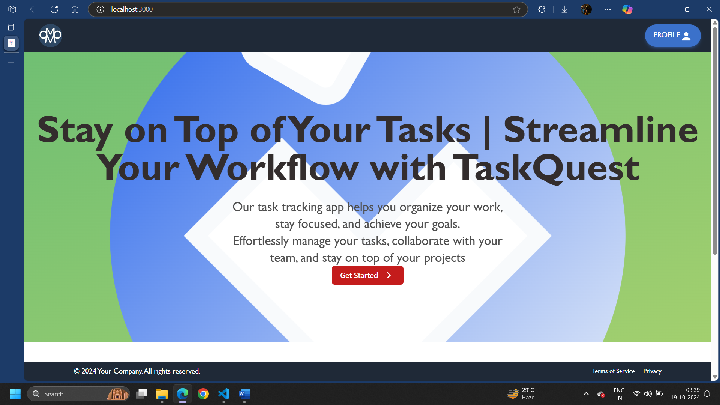

* Signup screen

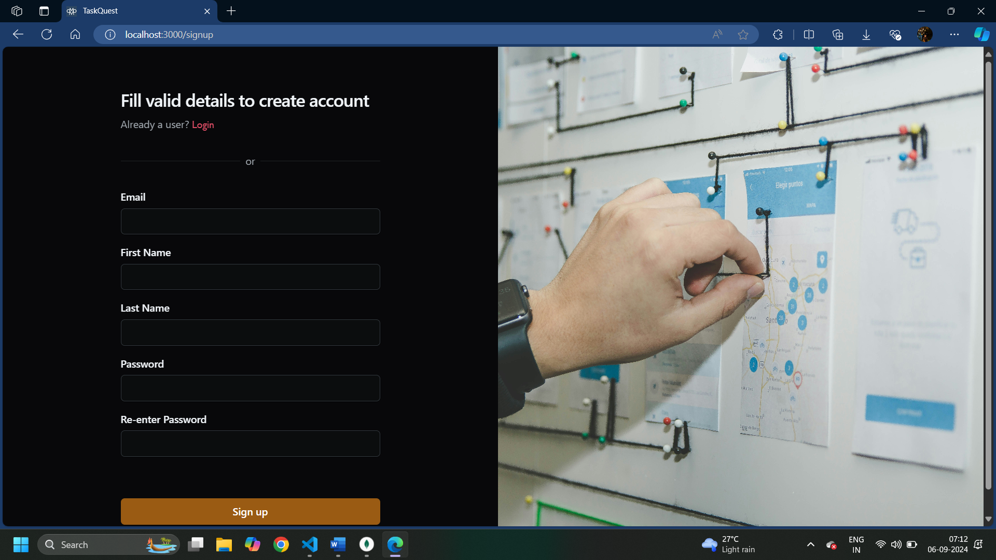

* Role based Login screen

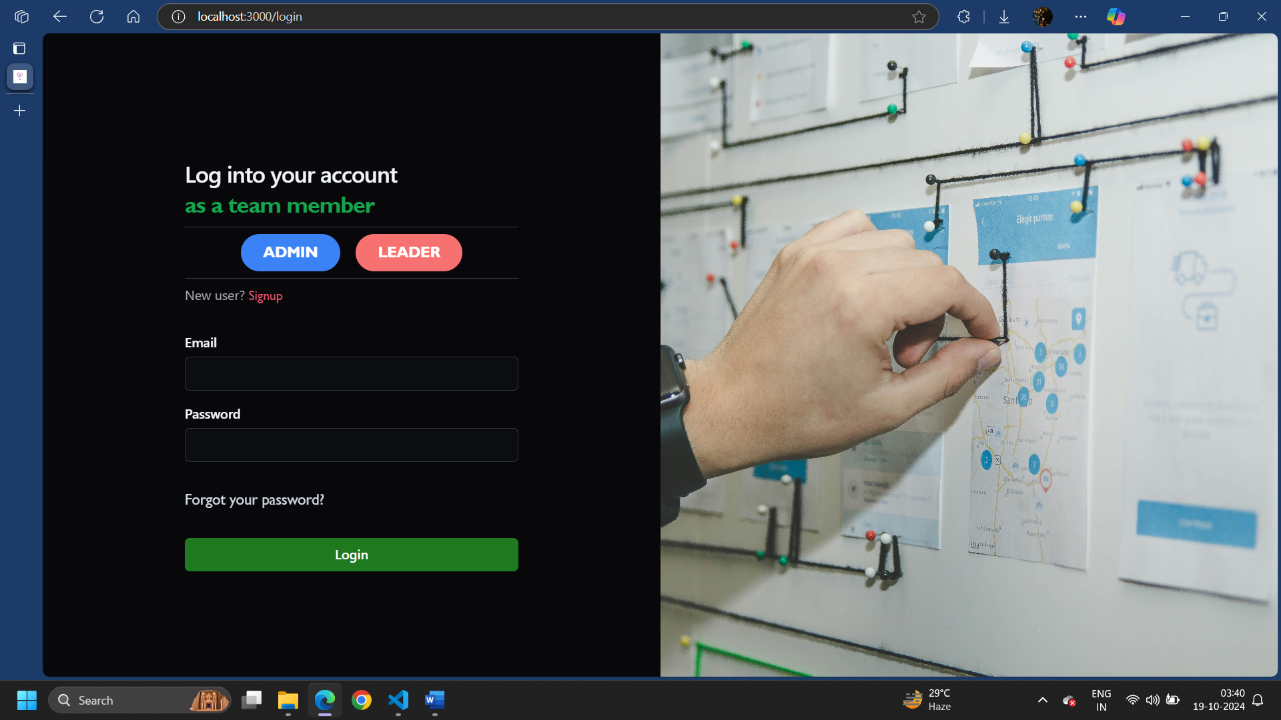

* Forgot password

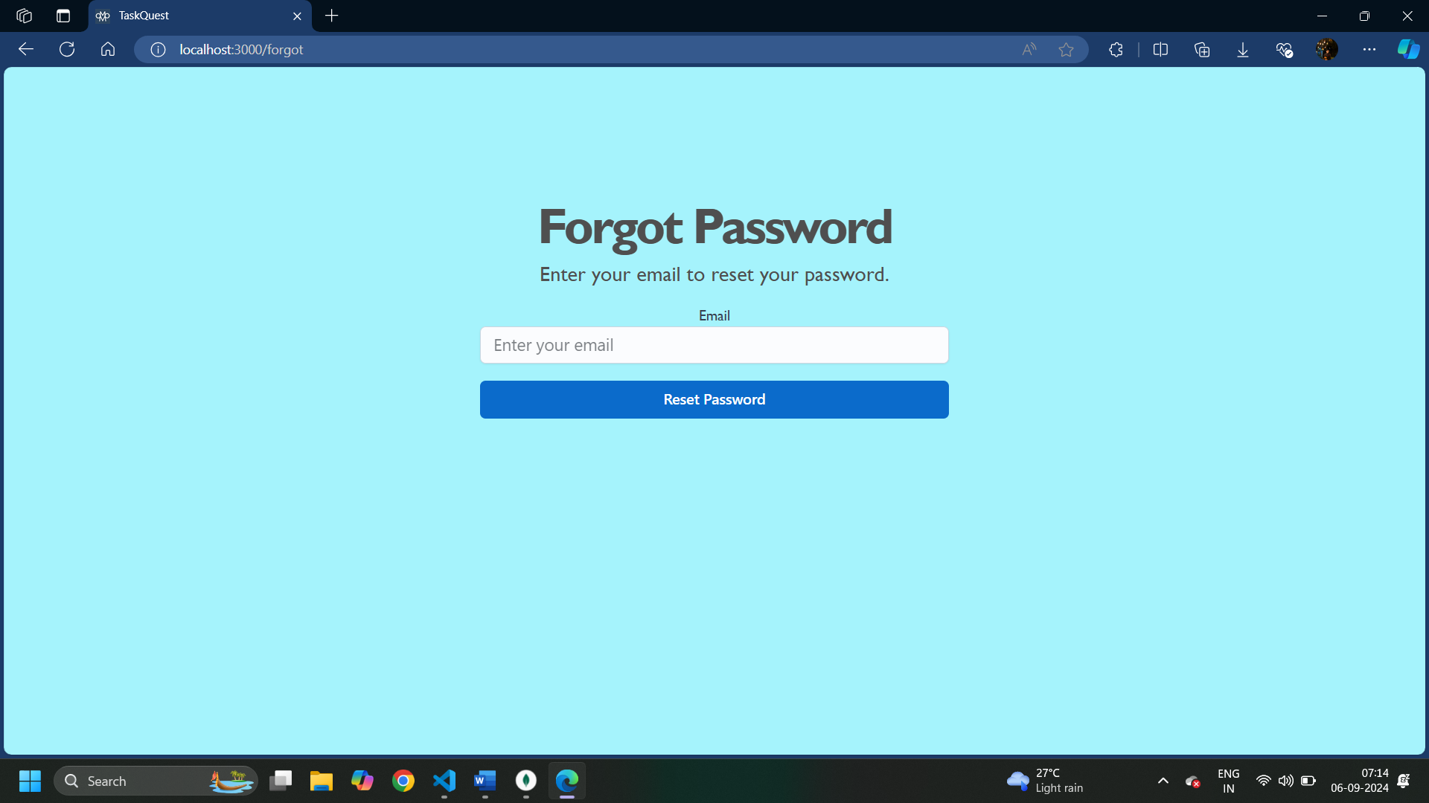

* Admin Dashboard

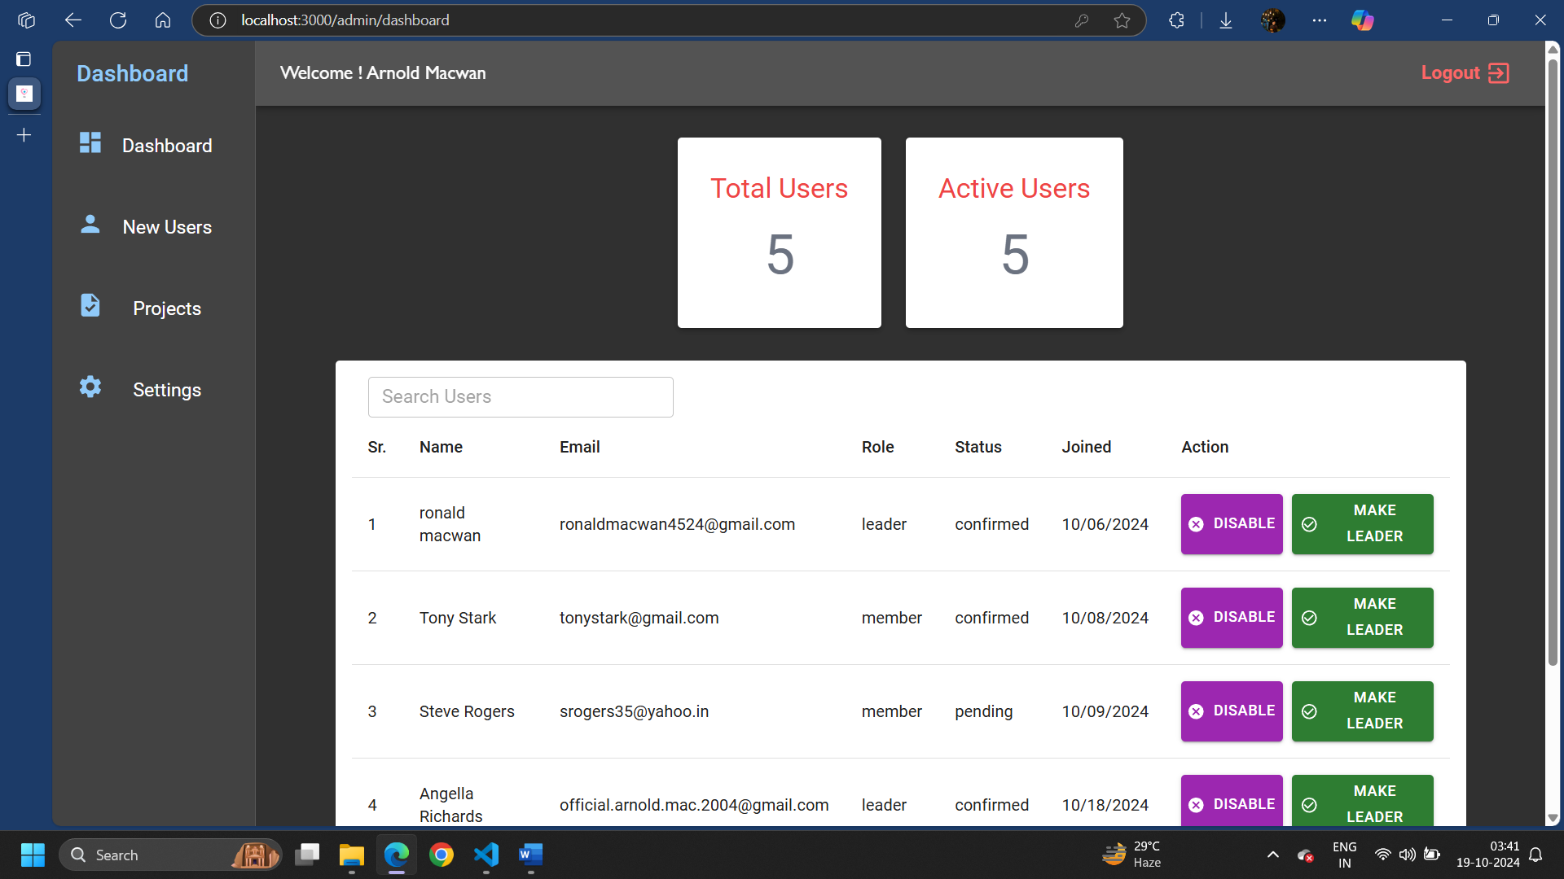

* Add Project

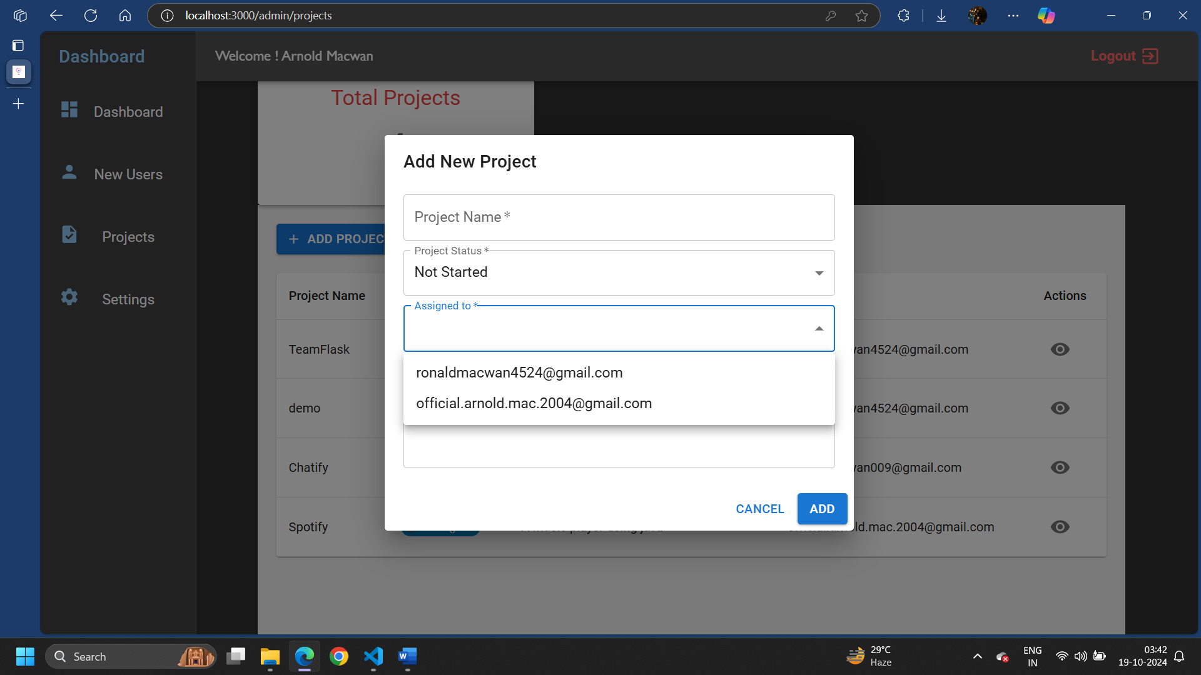

* Leader Dashboard

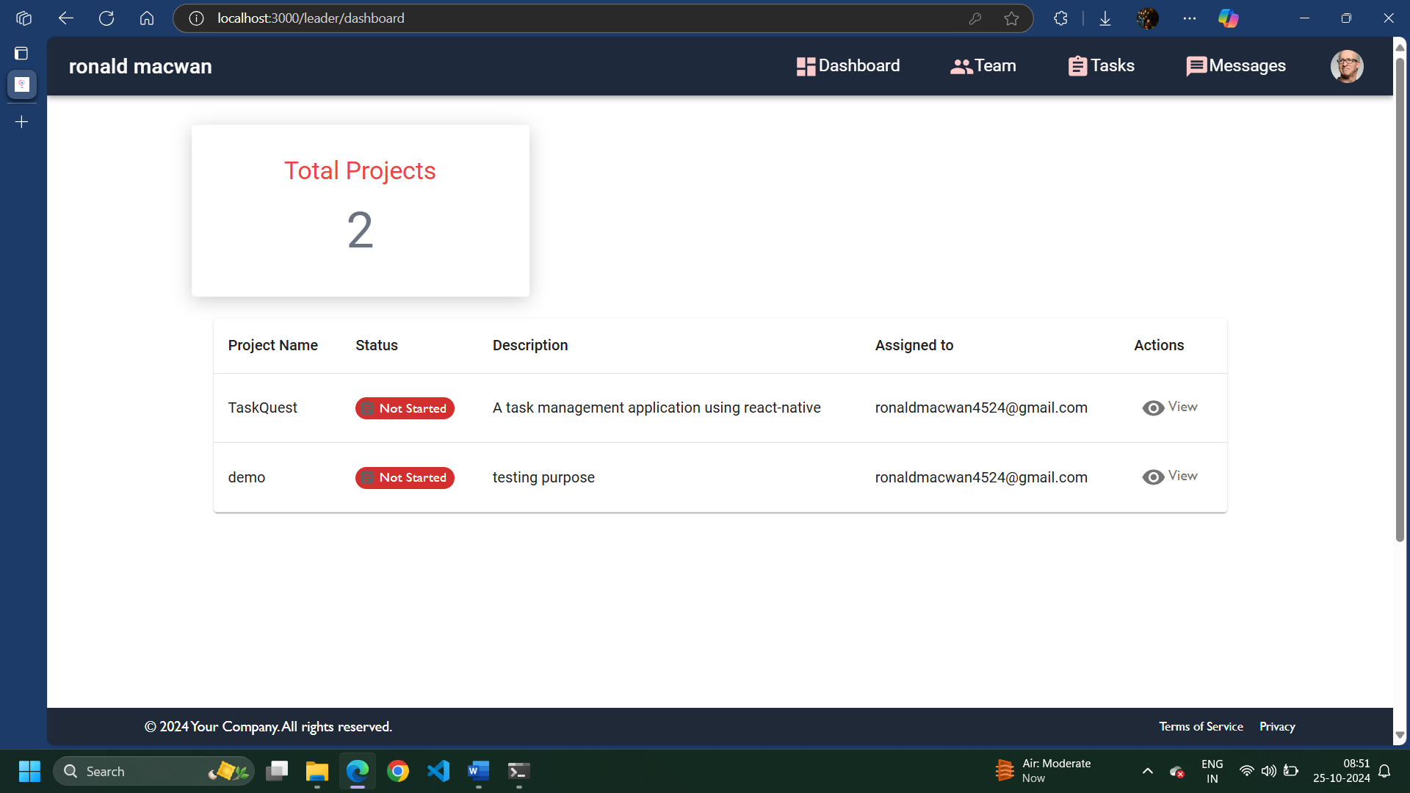

* Team List

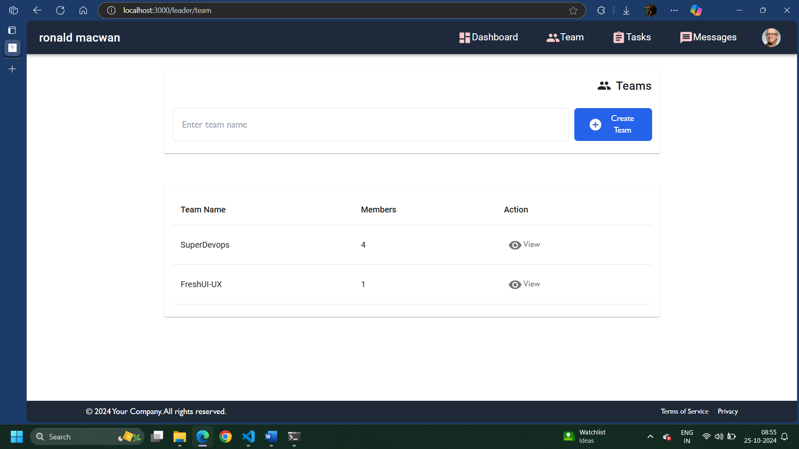

AGILE DOCUMENTATION

|  |  |
| --- | --- |
| Project name | Task management – with collaboration |
| Guide |  |
| Project expected start date | 10-8-2024 |
| Project expected end date | 15-11-2024 |
| Project Scope | * Integration of collaborative platform * Custom Admin UI deployment * Report download * Safe & secure storing user information |
| Project mission | Our mission is to provide such a platform so that every user using the system will get the enhanced online service to organise their tasks accordingly their customization. |
| Project vision | Our vision is to provide user-friendly platform to newbies who face difficulties to manage and track their tasks. |

1. Project charter
2. Project Roadmap

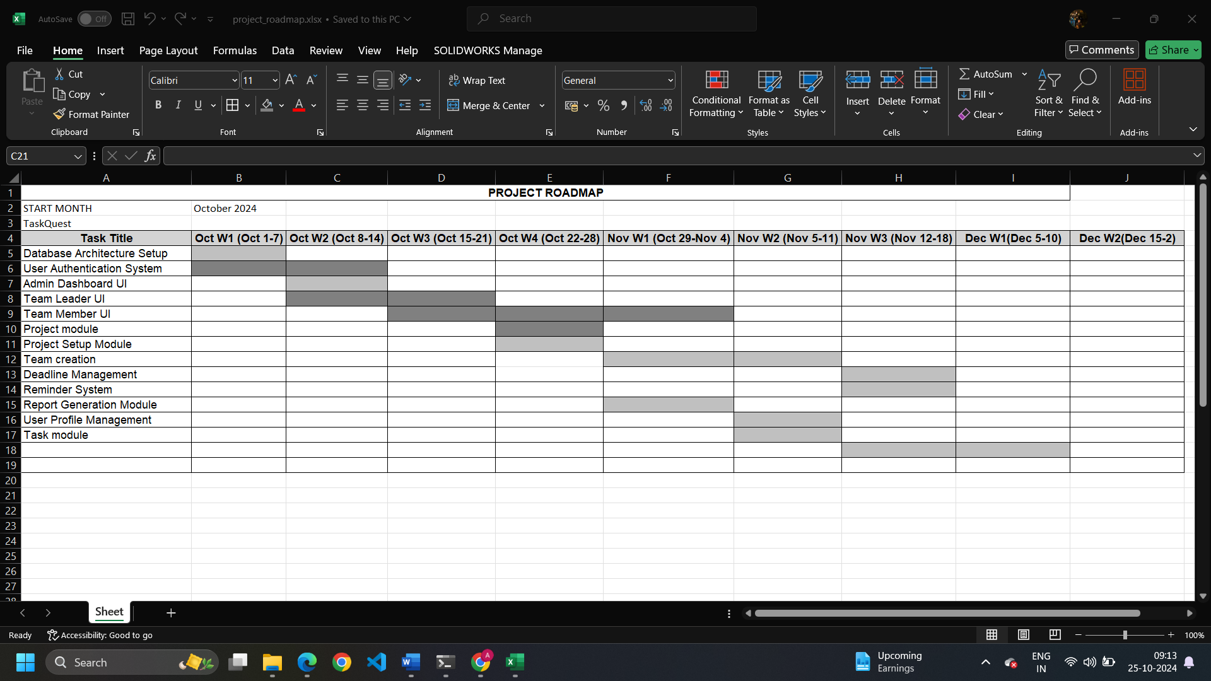

1. Sprint table

|  |  |  |  |  |  |
| --- | --- | --- | --- | --- | --- |
| Id # | Task | Assigned to | Status | Estimated time(hours) | Story points |
| 1. | Database setup | Mathan | Completed | 3 | 5 |
| 2. | Authentication | Arnold | Completed | 8 | 8 |
| 3. | Admin Dashboard UI | Manthan | Completed | 6 | 7 |
| 4. | Forgot password | Arnold | Completed | 2 | 6 |
| 5. | Leader Dashboard UI | Arnold | Completed | 4 | 7 |
| 6. | Member Dashboard UI | Manthan | Completed | 6 | 8 |
| 7. | Profile management | Arnold | Delayed | 3 | 4 |
| 8. | Task module | Arnold & Manthan | Delayed | 9 | 8 |
| 9. | Generate report | Arnold | Ongoing | 2 | 6 |
| 10. | Deadline management | Arnold | Delayed | 3 | 7 |
| 11. | Reminder/notification | Manthan | Delayed | 4 | 7 |

Proposed Enhancements

* System is focusing on resolving current issues and enhancing functionality.
* Improvements include more data security, efficient analytics using machine learning.
* Implement Role based access control.
* Going to add basic real time chat in the system.

Conclusion

* A task management system is essential for improving product development, data security, and real time collaborations. we aim to deliver a more efficient, user-friendly, and scalable solution.